Your Article for Business & Information Systems Engineering

John Smith^{1*}, Jane Doe¹, and Joe Scientist²
¹Department of Chemistry, University of Wherever,
An Unknown Address, Wherever, ST 00000, USA
²Another Unknown Address, Nowhere, 99999, Germany
∗To whom correspondence should be addressed; E-mail: jsmith@wherever.edu.

This document is a very basic template for setting up your Business & Information Systems Engineering paper in Word. Please read the instructions below on how to use this template carefully. Place your abstract here. We are looking forward to receive your submission!
Keywords - Place 4-6 keywords here, separated by semicolons
Acknowledgements: I’d like to say thanks to... Please add the acknowledgements only in the final version after acceptance in case they would identify or hint towards the authors.

Introduction
This document is a very basic template for submissions to Business & Information Systems Engineering. Please use this .docx-file as a template for your manuscript, cutting and pasting your content into the file at the appropriate places. The following sections give you some details on how to use the template.

Formalities

Formatting your Manuscript
Please use the styles defined in this document to format your text, headers, references and other elements of your manuscript. If you like, you can also enumerate the sections, subsection, etc.

Length
For guidelines regarding the length of articles, please visit our author guidelines on our homepage: http://bise-journal.com/author_guidelines. Try to be concise and note that we assume a constant contribution/length ratio - shorter papers would be accepted with smaller contributions while long submissions are expected to have larger contributions.

Formatting Citations and References
Please format your citations according to the APA6 style. References in the text should look like Weinhardt, Kloker, Hinz, and van der Aalst (2020), and references in parentheses should look like (van der Aalst et al., 2018). The references in the reference list need to be sorted alphabetically.

Handling Figures and Tables
Please place the figures and tables within the text at the position they fit the most and do not put them at the end of the manuscript. Place headers for figures below the figure (see Fig. 1), headers for tables above the table (see Tab. 1). Figures and tables should be centered.
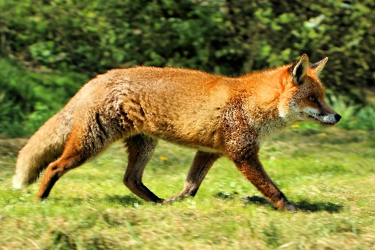
Figure 1: This is a figure header
Table 1: This is a table header
Data | Data | Data | Data
a_{1,1} | a_{1,2} | a_{1,…} | a_{1,n}
a_{2,1} | a_{2,2} | a_{2,…} | a_{2,n}
a_{…,1} | a_{…,2} | a_{m,…} | a_{m,n}

Other Formats or Templates
Business & Information Systems Engineering does not enforce you to use our templates. You can also submit manuscripts in your own formatting or other citation styles. However, we strongly encourage you to use our template. In case you use another formatting, you have to take special attention regarding the length restrictions. There is also a LATEX template you may use, if you feel more comfortable with LATEX. You’ll find the template on our homepage: http://bise-journal.com/author_guidelines

Before Submitting

Blind your Manuscript
Please make sure to blind your manuscript (this also includes the supplementary material and obvious self-citations). Manuscript that are not properly blinded will be desk-rejected immediately.

Select your Department
During the submission process, you will have to select a department. Please carefully read the departments descriptions on our homepage before submitting.

What to Submit
When submitting a Business & Information Systems Engineering manuscript, please do not forget to add a title page and a cover letter. The final version of your manuscript needs to be submitted in the form of the raw files (.docx or complete LATEX project).

References
van der Aalst, W. M., Becker, J., Bichler, M., Buhl, H. U., Dibbern, J., Frank, U., . . . Zdravkovic, J. (2018). Views on the Past, Present, and Future of Business and Information Systems Engineering. Business and Information Systems Engineering, 60(6), 443–477. doi: 10.1007/s12599-018-0561-1
Weinhardt, C., Kloker, S., Hinz, O., & van der Aalst, W. M. P. (2020). Citizen Science in Information Systems Research. Business & Information Systems Engineering, 61(4). doi: 10.1007/s12599-020-00663-y

